# ATM MANAGEMENT SYSTEM

**A PROJECT REPORT**

***Submitted by***

**S.TEJASWI(RA2211003011107) K.B.YASWANTH(RA2211003011104) V.YASWANTH(RA2211003011123)**

*Under the guidance of*

**Dr.M.VIJAYA LAKSHMI**

(Assistant Professor, Department of Computing Technologies) 21CSC202J - OPERATING SYSTEMS

***In partial satisfaction of the requirements for the degree of***

## BACHELOR OF TECHNOLOGY

**In**

## COMPUTER SCIENCE AND ENGINEERING



**DEPARTMENT OF COMPUTING TECHNOLOGIES COLLEGE OF ENGINEERING AND TECHNOLOGY SRM INSTITUTE OF SCIENCE AND TECHNOLOGY KATTANKULATHUR– 603 203**

## SEP 2023

1



# SRM INSTITUTE OF SCIENCE AND TECHNOLOGY KATTANKULATHUR–603 203

## BONAFIDE CERTIFICATE

Certified that 21CSC202J project report titled “**ATM MANAGEMENT SYSTEM**” is the bonafide work of **S.TEJASWI(RA2211003011107) , K.B.YASWANTH(RA2211003011104)**and**V.YASWANTH(RA221100301**

**1123)** who carried out the project work under my supervision. Certified further, that to the best of my knowledge, the work reported here in does not form part of any other thesis or dissertation on the basis of which a degree or award was conferred on an earlier occasion for this or any other candidate.

**Dr. M.VIJAYA LAKSHMI SUPERVISOR**

Assistant Professor

Department of Computing Technologies

**Dr. M. KANCHANA PANEL HEAD**

Associate Professor

Department of Computing Technologies

**Dr. M. PUSHPALATHA**

**HEAD OF THE DEPARTMENT**

Department of Computing Technologies

2

Department of Computing Technologies

# SRM Institute of Science and Technology Own Work Declaration Form

**Degree/Course:** B.Tech in Computer Science and Engineering S**tudent Names:** S.TEJASWI,K.B.YASWANTH,V.YASWANTH

**Registration Number:** RA2211003011107,RA2211003011104,RA221100301123

**Title of Work :** ATM MANAGEMENT SYSTEM

I/We hereby certify that this assessment compiles with the University’s Rules and Regulations relating to Academic misconduct and plagiarism, as listed in the University Website, Regulations, and the Education Committee guidelines.

I / We confirm that all the work contained in this assessment is our own except where indicated and that we have met the following conditions:

* References/lists all sources as appropriate
* Referenced and put in inverted commas all quoted text (from books, web, etc.)
* Given the sources of all pictures, data, etc that are not my own.
* Not making any use of the report(s) or essay(s) of any other student(s)either past or present
* Acknowledged in appropriate places any help that I have received from others (e.g fellow students, technicians, statisticians, external sources)
* Compiled with any other plagiarism criteria specified in the Course handbook / University website

I understand that any false claim for this work will be penalized in accordance with the University policies and regulations.

|  |
| --- |
| **DECLARATION:** |
| I am aware of and understand the University's policy on academic misconduct and plagiarism, and I certify that, except where indicated by referring, this assessment is my / our work, and that I have followed the good academic practices outlined above.  **Student 1 Signature:**  **Student 2 Signature:**  **student 3 signature:**  **Date:** |
| If you are working in a group, please write your registration numbers and sign with the  date for every student in your group. |

## ACKNOWLEDGEMENT

We express our humble gratitude to **Dr. C. Muthamizhchelvan**, Vice-Chancellor, SRM Institute of Science and Technology, for the facilities extended for the project work and his continued support.

We extend our sincere thanks to Dean-CET, SRM Institute of Science and Technology, **Dr.**

**T. V. Gopal**, for his invaluable support.

We wish to thank **Dr. Revathi Venkataraman**, Professor and Chairperson, School of Computing, SRM Institute of Science and Technology, for her support throughout the project work.

We are incredibly grateful to our Head of the Department, **Dr. M. Pushpalatha,** Professor, Department of Computing Technologies, SRM Institute of Science and Technology, for her suggestions and encouragement at all the stages of the project work.

We want to convey our thanks to our Project Coordinators, **S. Godfrey Winster, Dr.**

**M. Baskar, Dr. P. Murali, Dr. J. Selvin Paul Peter, Dr. C. Pretty Diana Cyril and Dr.G.Padmapriya,** Panel Head, **Dr. A. Kowsigan**, Associate Professor and Panel Members, **Dr. M. Vijayalakshmi** Assistant Professor, Mrs **A. Mariya Nancy** Assistant Professor and **Dr.**

**N. Arunachelam** Assistant Professor, Department of Computing Technologies, SRM Institute of Science and Technology, for their inputs during the project reviews and support.

We register our immeasurable thanks to our Faculty Advisor, **Dr.B.KANISHA** Assistant Professor, Department of Computing Technologies, SRM Institute of Science and Technology, for leading and helping us to complete our course.

Our inexpressible respect and thanks to our guide, **Dr. M.VIJAYA LAKSHMI**, Assistant Professor, Department of Computing Technologies, SRM Institute of Science and Technology, for providing us with an opportunity to pursue our project under his / her mentorship. He / She provided us with the freedom and support to explore the research topics of our interest. His / Her passion for solving problems and making a difference in the world has always been inspiring.

We sincerely thank all the staff and students of Computing Technologies Department, School

of Computing, S.R.M Institute of Science and Technology, for their help during our project. Finally,

we would like to thank our parents, family members, and friends for their unconditional love, constant support and encouragement.

**S.TEJASWI [Reg. No: RA2211003011107]**

**K.B.YASWANTH [Reg. No: RA2211003011104]**

**V.YASWANTH [Reg.No: RA221100301123]**

**TABLE OF CONTENTS**

|  |  |  |
| --- | --- | --- |
| ***C.NO*** | ***TITLE*** | ***PAGE NO:*** |
|  | Abstract | 7 |
| **1.** | **INTRODUCTION**  1.1 General | 8 |
|  | 1.2 Purpose | 8 |
|  | 1.3 Scope | 9 |
| **2.** | **LITERATURE REVIEW** | 10 |
| **3.** | **PROPOSED METHODOLOGY** | 11 |
| **4.** | **RESULTS** | 12 |
| **5.** | **CONCLUSION** | 19 |
| **6.** | **FUTURE SCOPE** | 20 |
| **7.** | **REFERENCES** | 21 |

**ABSTRACT**

The ATM Management System in an operating system is a comprehensive software solution designed to efficiently handle Automated Teller Machine (ATM) operations. This system facilitates secure and user-friendly interactions between customers and ATMs, ensuring seamless financial transactions. Key features include user authentication, balance inquiries, cash withdrawals, fund transfers, and transaction history retrieval. The system integrates with banking databases to ensure real-time updates and accuracy. Security measures, such as PIN verification and transaction encryption, are implemented to safeguard user data. Additionally, the ATM Management System employs robust error handling and recovery mechanisms to enhance reliability. Through a well-designed graphical user interface, customers can interact with the ATM easily, making transactions convenient and enhancing the overall banking experience. The system contributes to operational efficiency, minimizes downtime, and promotes a secure and convenient environment for users to perform their financial activities The ATM Management System in an operating system is a comprehensive software solution designed to efficiently handle Automated Teller Machine (ATM) operations. This system facilitates secure and user-friendly interactions between customers and ATMs, ensuring seamless financial transactions. Key features include user authentication, balance inquiries, cash withdrawals, fund transfers, and transaction history retrieval. The system integrates with banking databases to ensure real-time updates and accuracy. Security measures, such as PIN verification and transaction encryption, are implemented to safeguard user data. Additionally, the ATM Management System employs robust error handling and recovery mechanisms to enhance reliability. Through a well-designed graphical user interface, customers can interact with the ATM easily, making transactions convenient and enhancing the overall banking experience. The system contributes to operational efficiency, minimizes downtime, and promotes a secure and convenient environment for users to perform their financial activities

### INTRODUCTION

#### GENERAL

ATM management systems play a pivotal role in ensuring the smooth and secure operation of Automated Teller Machines (ATMs) in the financial sector. These systems are extensively utilized to streamline customer transactions, encompassing tasks such as cash withdrawals, balance inquiries, fund transfers, and account statements. With real-time connectivity to banking databases, ATM management systems facilitate instantaneous updates of user account information, ensuring accurate and up-to-date financial records. Security features, including PIN verification and encryption, safeguard sensitive customer data, fortifying the overall integrity of the banking process. The ATM Management System serves a pivotal role in the banking industry, providing a range of functionalities that enhance both customer experience and operational efficiency. Firstly, it enables users to perform basic transactions such as cash withdrawals, balance inquiries, and fund transfers, offering unparalleled convenience. Moreover, the system facilitates secure authentication processes, safeguarding customer accounts through features like PIN verification and encryption protocols. Beyond customer interactions, ATM management streamlines cash replenishment processes, ensuring ATMs are adequately funded to meet user demands. It supports comprehensive transaction logging, allowing banks to track user activity for auditing purposes and compliance with regulatory standards. The system's modular architecture promotes scalability, enabling banks to integrate new features and technologies seamlessly. Anti-skimming technologies and real-time monitoring further fortify the system against fraudulent activities. Overall, ATM Management Systems contribute significantly to the banking sector by automating routine tasks, enhancing security, and providing customers with accessible and efficient financial services

#### PURPOSE

The primary purpose of an ATM Management System is to streamline and automate the operations of Automated Teller Machines (ATMs). It facilitates secure and efficient financial transactions, allowing users to perform tasks such as cash withdrawals, balance inquiries, and fund transfers. The system ensures the availability of funds by managing cash dispensers and automates cash replenishment processes. Through robust security measures like PIN verification and encryption, it safeguards customer information during transactions. Additionally, the system supports real-time monitoring, enabling quick detection of issues and fraudulent activities. Its overarching goal is to enhance operational efficiency, provide a seamless user experience, and ensure the secure and reliable functioning of ATMs in the banking environment

* 1. Scope

|  |  |  |  |  |  |  |  |  |  |  |  |  |  |  |
| --- | --- | --- | --- | --- | --- | --- | --- | --- | --- | --- | --- | --- | --- | --- |
|  | 1. | **Transaction Processing:** | | | | | | | |  | | | | |
|  | | |  | * Facilitating a wide range of financial transactions, including cash withdrawals, fund   transfers, balance inquiries, and bill payments, to enhance user convenience. | | | | | | | | | | |
|  | 2. | **Security Measures:** | | | | |  | | | | | | | |
|  | | |  | * Implementing robust security protocols such as PIN verification, encryption, and real- time monitoring to safeguard customer information and prevent fraudulent activities. | | | | | | | | | | |
|  | 3. | **Cash Management:** | | | | |  | | | | | | | |
|  | | |  | * Optimizing cash handling processes, managing cash dispensers, and automating cash replenishment to ensure ATMs are adequately funded and operational. | | | | | | | | | | |
|  | 4. | **User Authentication:** | | | | | |  | | | | | | |
|  | | |  | * Providing secure user authentication mechanisms to validate customer identities and   ensure authorized access to ATM services. | | | | | | | | | | |
|  | 5. | **Maintenance and Monitoring:** | | | | | | | | | |  | | |
|  | | |  | * Enabling efficient remote monitoring of ATM health and performance, as well as   automated error detection and recovery mechanisms to minimize downtime. | | | | | | | | | | |
|  | 6. | **Integration with Banking Systems:** | | | | | | | | | | |  | |
|  | | |  | * Integrating seamlessly with core banking systems to ensure real-time updates, accurate transaction records, and consistency in user account information. | | | | | | | | | | |
|  | 7. | **Compliance and Reporting:** | | | | | | | | |  | | | |
|  | | |  | * Supporting compliance with regulatory standards by maintaining transaction logs, facilitating audits, and generating reports for regulatory authorities. | | | | | | | | | | |
|  | 8. | **Scalability:** | | |  | | | | | | | | | |
|  | | |  | * Allowing for scalability to accommodate evolving technologies, additional services, and   an increasing number of ATMs as the banking infrastructure expands. | | | | | | | | | | |
|  | 9. | **Customer Experience Enhancement:** | | | | | | | | | | | |  |
|  | | |  | * Focusing on user-centric design and functionality to provide a seamless, reliable, and   convenient experience for customers conducting financial transactions. | | | | | | | | | | |
|  | 10. | **Fraud Prevention:** | | | |  | | | | | | | | |
|  | | |  | * Incorporating anti-skimming technologies and advanced fraud detection mechanisms to protect customers and the financial institution from unauthorized access and   fraudulent activities. | | | | | | | | | | |
|  | 11. | **Remote Management:** | | | | | | |  | | | | | |
|  | | |  | * Supporting remote management capabilities, allowing banks to update software, configure settings, and perform maintenance tasks without physical intervention at   each ATM location. | | | | | | | | | | |

# LITERATURE REVIEW

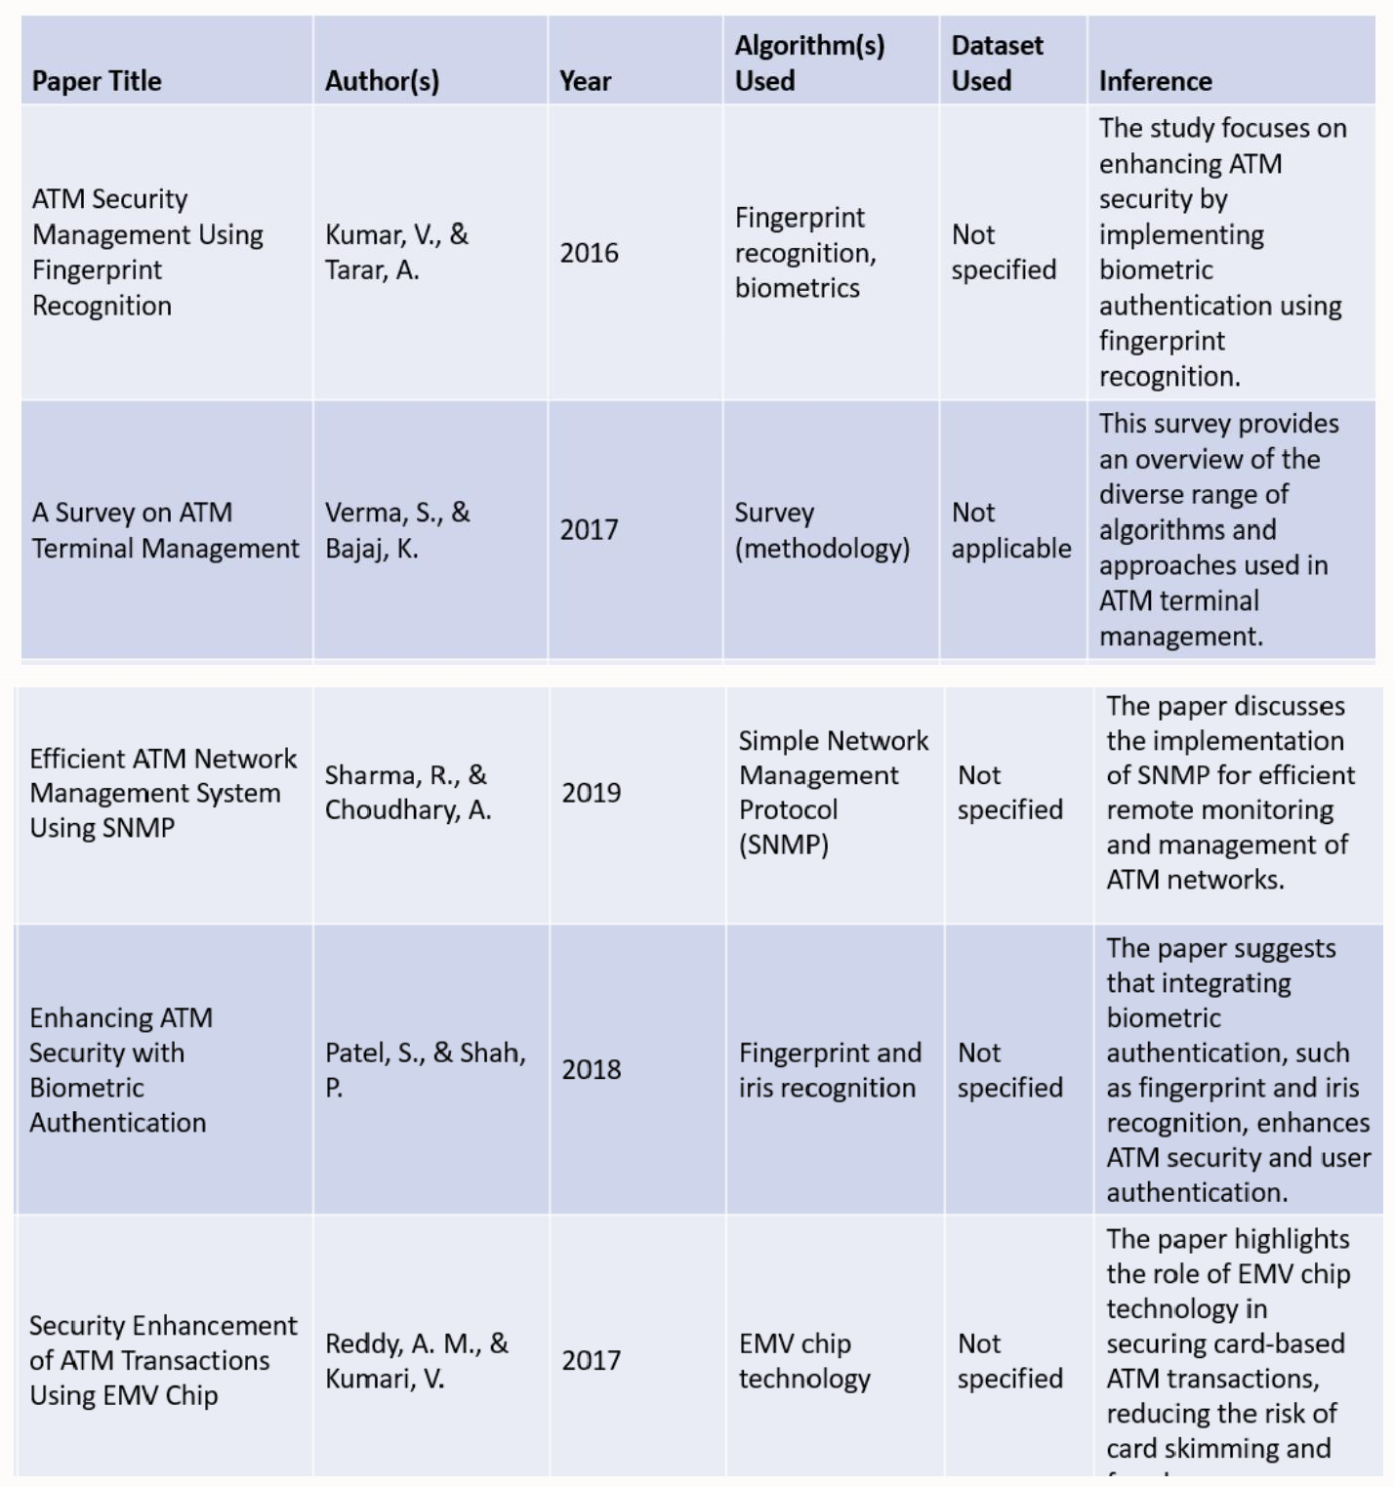

1. **PROPOSED METHODOLOGY**

* Real-Time Operating Systems (RTOS):
* Many ATMs run on real-time operating systems to ensure prompt response to user transactions and to meet the strict timing

requirements. RTOS guarantees that tasks are executed within specific time constraints.

* Network Management Protocols:
* SNMP (Simple Network Management Protocol) is commonly used to manage and monitor network devices, including ATMs.

It allows network administrators to collect data, set configurations, and diagnose issues.

* Data Encryption:
* To secure data transmission, encryption methods like SSL/TLS are used to protect communication between ATMs and the

central server.

* Transaction Logging:
* All ATM transactions are logged, and these logs are maintained for auditing purposes.

Transaction log analysis is

used for security and compliance monitoring

thread.h: This library is used for multi-threading in C. It provides functions and types for creating and

managing threads. In your code, it's used for creating and managing threads with functions like pthread_create and pthread_join

* semaphore.h: The semaphore.h library is used to work with semaphores, which are synchronization

mechanisms for controlling access to shared resources in multi-threaded environments. In your code, it's

used for creating and managing a semaphore with functions like sem_init, sem_wait, and sem_post.

* Security Policies and Procedures:
* Formal security methodologies and policies, such as ISO 27001, are implemented to ensure the

# RESULTS

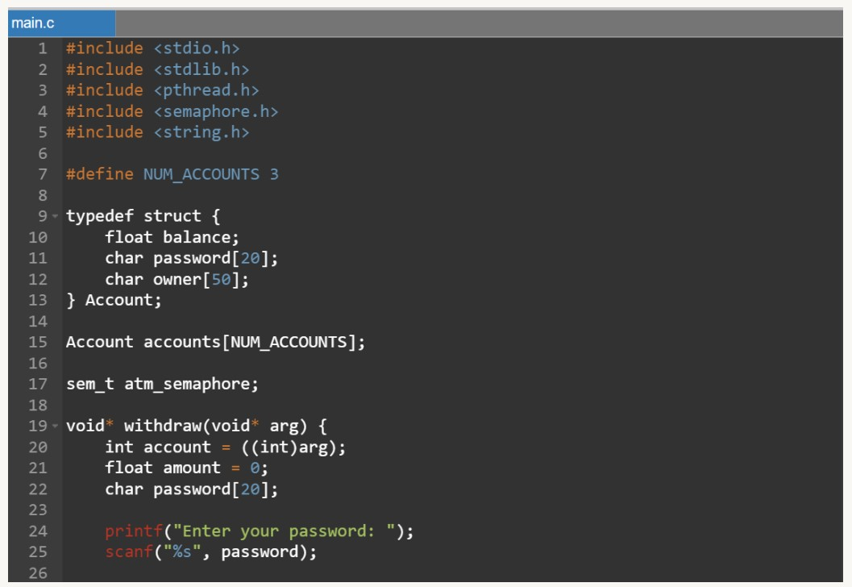

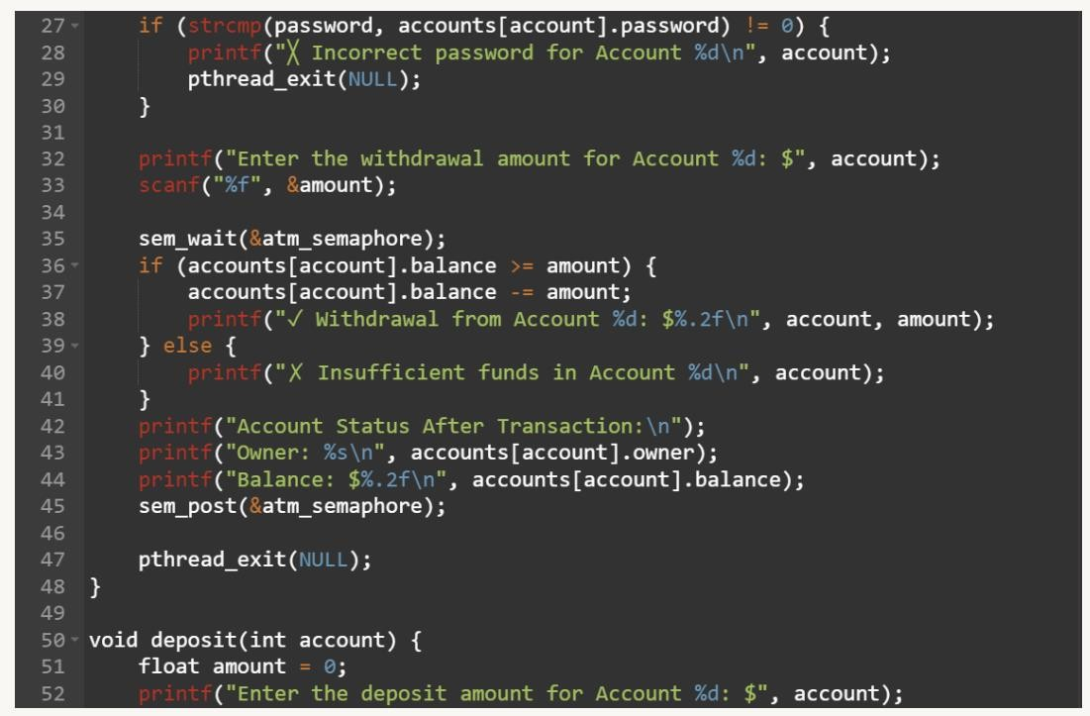

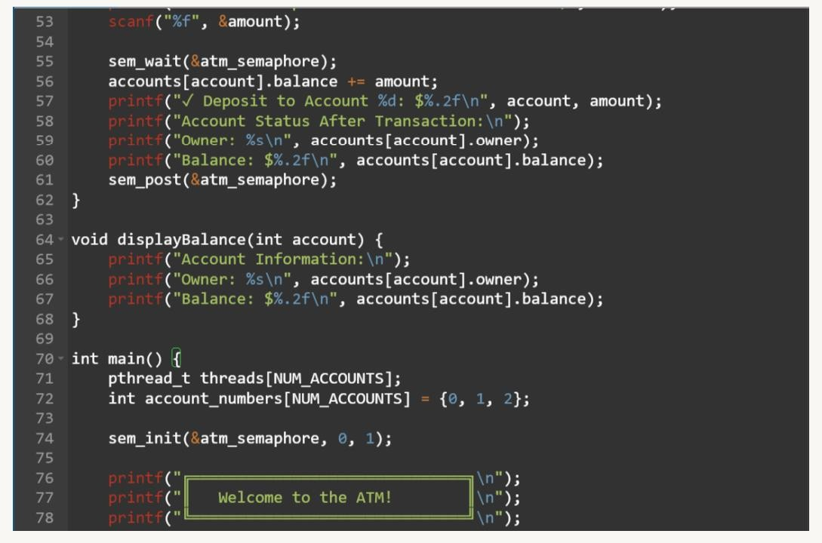

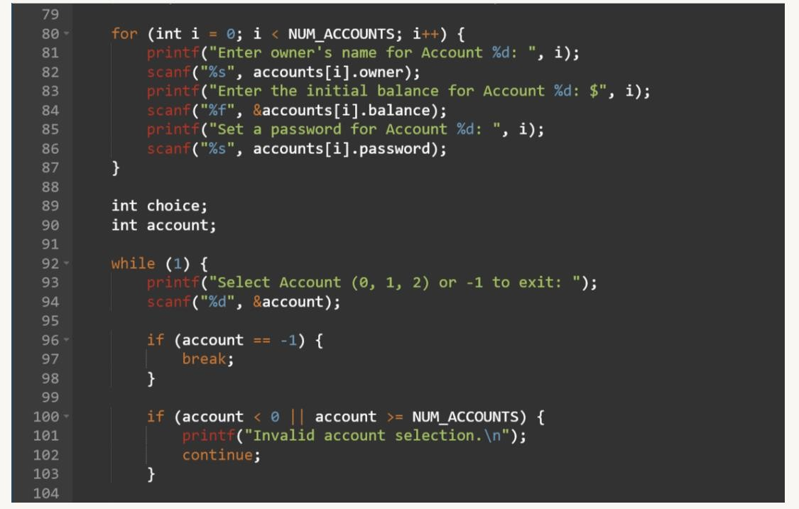

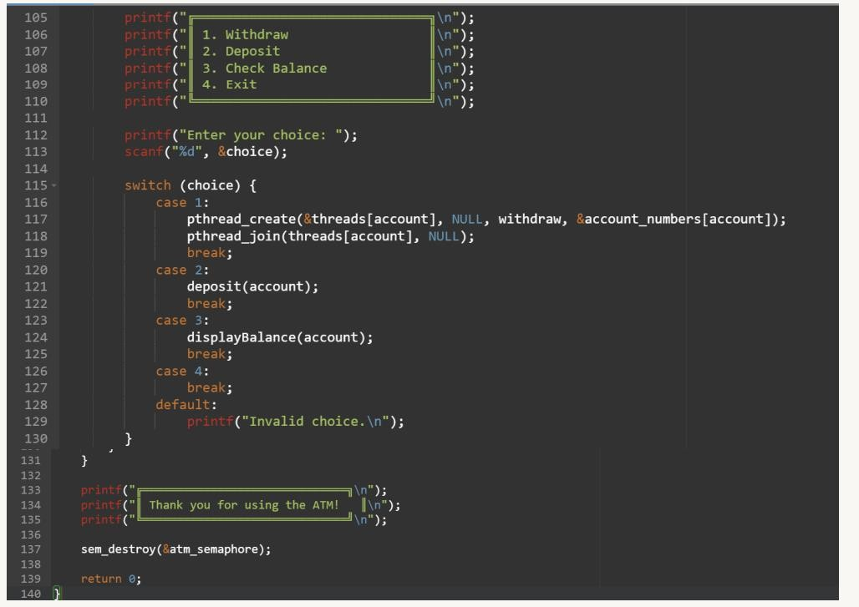

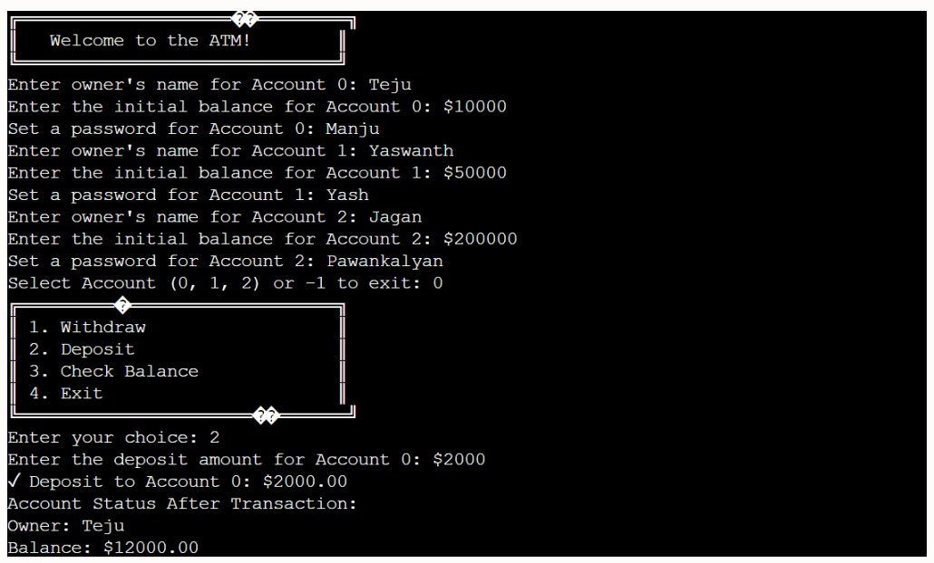

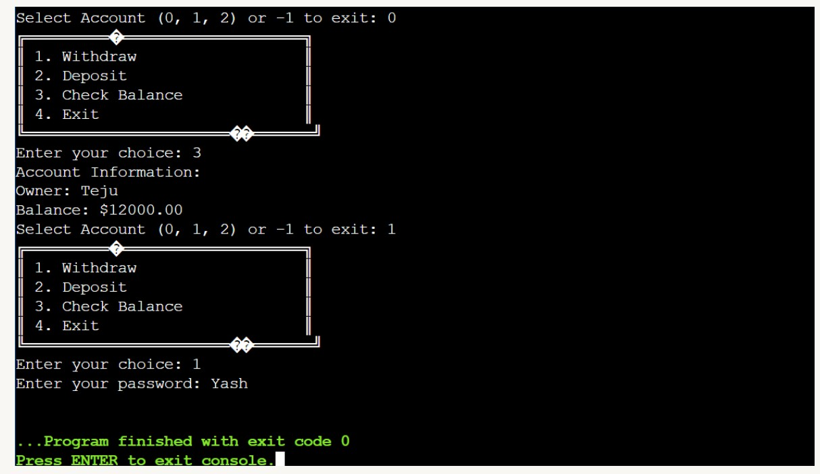

1. **CONCLUSION**

In conclusion, the ATM Management System mini project serves as an exemplary application within the domain of Operating Systems, showcasing its vital role in the seamless functioning of Automated Teller Machines (ATMs) in the banking sector. This project has successfully demonstrated the integration of essential OS principles to enhance both operational efficiency and user experience. By automating routine tasks such as transaction processing, cash management, and error recovery, the system significantly reduces manual intervention, streamlining day-to-day operations. The incorporation of robust security measures, including PIN verification, encryption, and real-time monitoring, ensures the integrity of user data and safeguards against potential fraudulent activities. Moreover, the ATM Management System underscores the importance of remote management capabilities, allowing for the efficient monitoring and maintenance of ATMs without the need for physical intervention at each location. This aspect aligns with modern OS concepts, promoting centralized control and adaptability in response to dynamic banking environments. The system's scalability and interoperability with diverse ATM models emphasize its potential for integration with evolving technologies and expanding banking infrastructures. Additionally, the project has showcased the significance of real-time updates and integration with core banking systems, ensuring accurate transaction records and providing users with a reliable and up-to-date banking experience. The implementation of anti-skimming technologies and advanced fraud prevention mechanisms contributes to a secure financial environment, further highlighting the system's commitment to user protection. In summary, the ATM Management System mini project serves as a comprehensive illustration of how Operating System principles can be applied to optimize the functionality of ATMs, resulting in enhanced security, operational efficiency, and overall user satisfaction within the intricate landscape of modern banking. This project serves as a valuable learning experience, showcasing the practical application of OS concepts in the development of robust and user-centric financial systems. Remote management capabilities showcase the adaptability of the system, minimizing physical interventions and promoting a cost-effective maintenance model. The project's scalability and interoperability underscore its potential to evolve alongside technological advancements and expanding banking infrastructures. Real-time updates and integration with core banking systems contribute to a reliable and dynamic user experience. Furthermore, the inclusion of anti-skimming technologies demonstrates a commitment to staying ahead of potential security threats, enhancing the system's resilience

# FUTURE SCOPE

Biometric Authentication: Integration of advanced biometric authentication methods, such as fingerprint or facial recognition, for enhanced security.

Blockchain Integration: Implementing blockchain technology to ensure secure and transparent transaction processing.

Contactless Transactions: Expanding support for contactless transactions, aligning with the growing trend of digital and mobile payments.

AI-Powered Predictive Maintenance: Utilizing artificial intelligence for predictive maintenance, reducing downtime and enhancing ATM reliability.

Personalized User Experiences: Customizing interfaces based on user preferences to provide a more personalized and user-friendly experience.

Cash Recycling Systems: Implementing advanced cash recycling mechanisms to optimize cash management and reduce operational costs.

Mobile App Integration: Seamless integration with mobile banking apps to enable users to initiate and track transactions directly from their smartphones.

Enhanced Data Analytics: Utilizing advanced data analytics to derive insights into user behavior, transaction patterns, and ATM performance for informed decision-making.

IoT Connectivity: Integrating Internet of Things (IoT) devices for real-time monitoring of ATM components and environmental factors.

Voice-Activated Transactions: Incorporating voice recognition technology for hands-free and accessible ATM interactions.

Multi-Currency Support: Offering multi-currency support to cater to international users and tourists.

Advanced Fraud Detection: Developing more sophisticated algorithms and machine learning models to detect and prevent evolving forms of fraud.

Augmented Reality Interfaces: Exploring the integration of augmented reality interfaces for interactive and immersive user experiences.

Green ATM Solutions: Implementing eco-friendly technologies to reduce energy consumption and environmental impact.

Tokenization for Security: Implementing tokenization techniques to enhance the security of sensitive data during transaction

# REFERENCES

[1].Tanenbaum, A. S., & Woodhull, A. S. (2014). Operating Systems: Design and Implementation. Pearson.

[2].Silberschatz, A., Galvin, P. B., & Gagne, G. (2018). Operating System Concepts. Wiley.

[3].Stallings, W. (2018). Operating Systems: Internals and Design Principles. Pearson.

[4]."Automated Teller Machine (ATM)." (n.d.). Investopedia. [Link to the Investopedia page on ATMs]

[5]."ATM Security Best Practices." (2019). ATMIA. [Link to the ATM Industry Association's guidelines on ATM security]

[6].Kaur, A., & Jain, A. (2016). "A Comprehensive Study on Security of Automated Teller Machine (ATM)." International Journal of Computer Applications, 136(4), 31-35.

[7].Sharma, R., & Litoriya, R. K. (2016). "ATM Security System using Fingerprint Biometric Identification." International Journal of Scientific and Research Publications, 6(2), 329-332.

[8].Banking Industry Standards and Regulations. (Ensure to refer to the specific standards and regulations relevant to your geographical location).

[9].Documentation from ATM Software Providers. (Reference the official documentation from companies providing ATM management software, if applicable.)

[10]."Future Trends in ATM Technology." (Consider articles or whitepapers from reputable technology and banking publications discussing future trends in ATM technology.)

[11].IEEExplore [12].Chegg